Peter Victoratos

2/7/2018

Lab02 Transformations

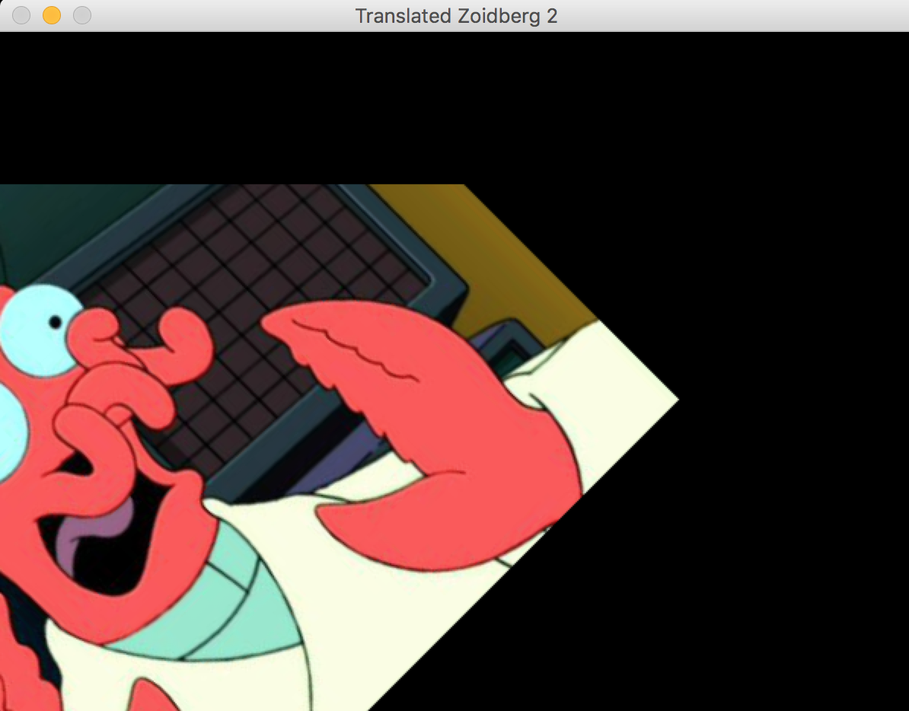 For Lab02 I first found some fun images off the internet and imported them into my script. Then I set variables for the sizes and centers of each image. I then defined some functions that could translate, rotate and filter the image in any fashion (Figures 1 & 2).

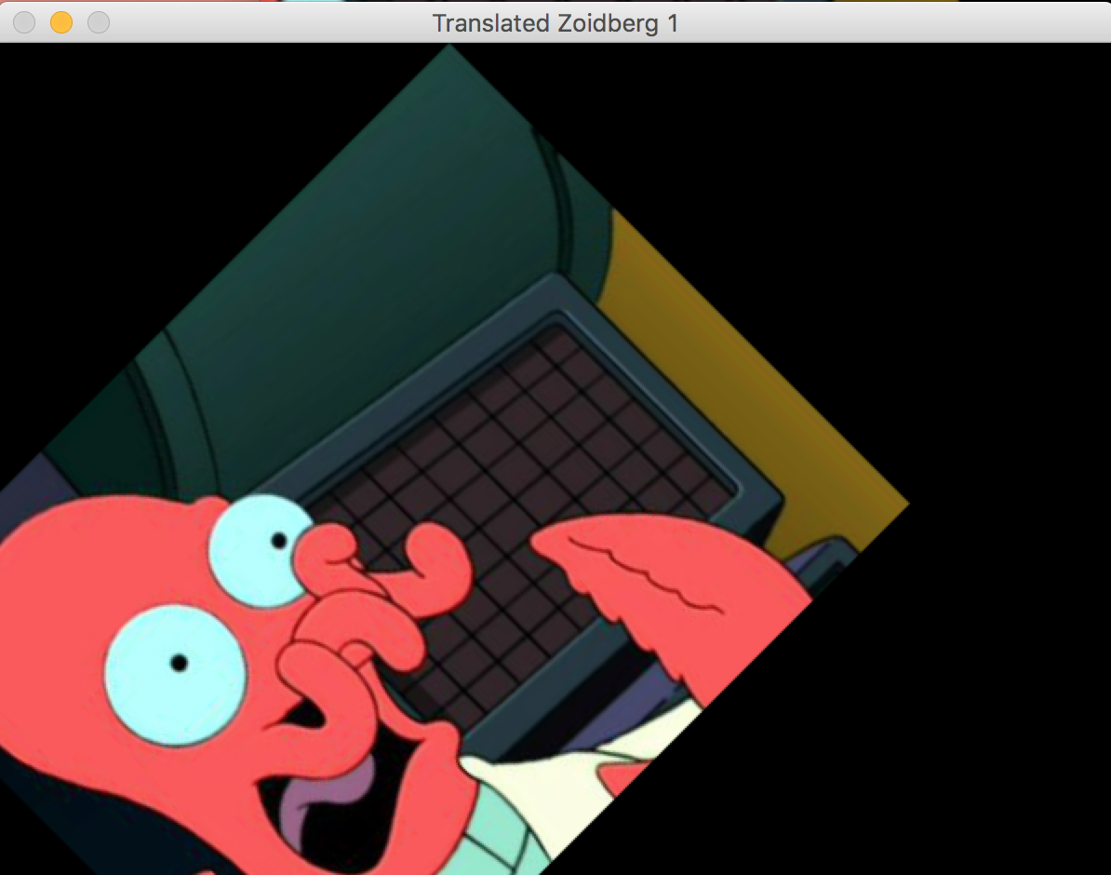

*Figures 1 & 2 : Figure 2 was translated then rotated which caused some clipping to occur*

*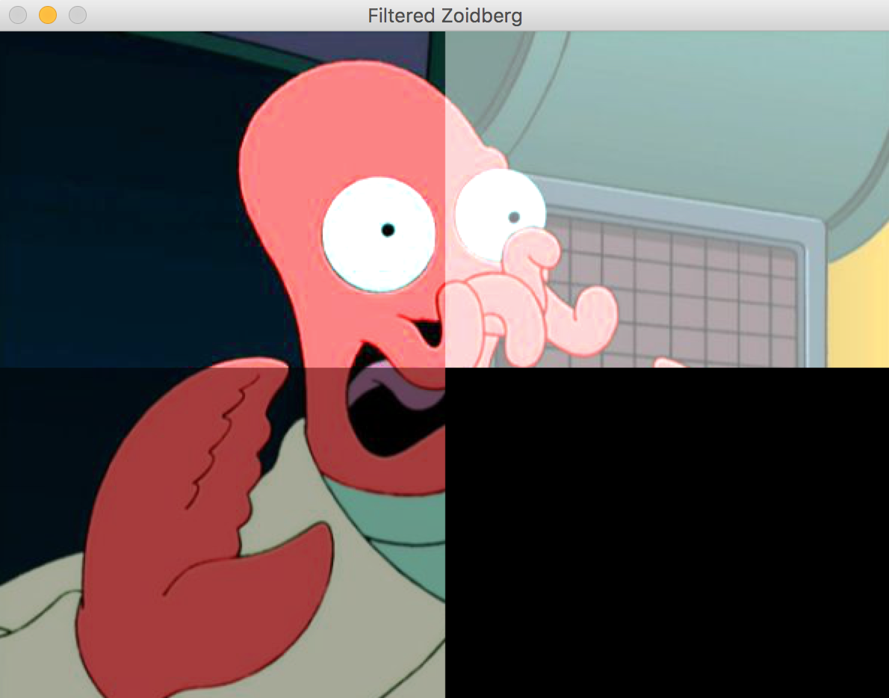*

The latter is the one I got stuck on. I managed to figure out the array splicing to apply each effect to only a single quadrant however the invert function did not work properly and just displays a black quadrant. ☹

Beyond this all I have is a completely black masked image.